

St. Timothy’s Pre-School

Parent Handbook

432 Van Buren St

Herndon, VA 20170

703-437-4767

Sttimothyspreschool432@gmail.com

**Table of Contents**

MISSION STATEMENT 1

STAFF 1

PROGRAM 1

SESSION HOURS 1

CURRICULUM 2

SHOW AND TELL 2

REGISTRATION 3

RECORD KEEPING 3

MEDICATIONS 4

ALLERGIES 4

ILLNESS 5

INFLUENZA PANDEMIC 5

HEAD LICE 5

COMMUNICATION 6

NEWLETTERS 6

DAILY CLASS SCHEDULE 6

HEALTH AND SAFETY 6

SCHOOL READINESS 6

POTTY TRAINING 7

ABSENCES 7

EXTENDED LEAVE AND WITHDRAWAL POLICY 7

CLOTHING 7

CARPOOL PROCEDURE 8

LATE PICKUP 9

HOMEROOM 10

SCHOOL PICTURES 10

PARTIES 10

FIELD TRIPS 11

SNACKS 11

SNOW DAYS AND LATE OPENINGS 12

SUPPLIES 13

TUITION 13

# APPENDIX I - LICENSING INFORMATION FOR PARENTS 14

APPENDIX II - GUIDELINES FOR DISCIPLINE 15

APPENDIX III - MEMORANDUM 16

APPENDIX IV - GENERAL EMERGENCY PROCEDURES 17

APPENDIX V **-** DAILY CLASS SCHEDULE 18

MISSION STATEMENT

St. Timothy’s Pre-school program provides an educational experience for children ages three through five. The pre-school is committed to meeting the individual needs and potential of each child in an inter-racial, non-denominational environment. At St. Timothy’s we strive to develop self -confidence, creativity and independence within every child.

St. Timothy’s Pre-school is a Virginia State Licensed program.

**STAFF**

St. Timothy’s staff of Head Teachers is degreed professional and experienced. Assistant Teachers have experience working with pre-school children and have collegiate backgrounds. Staff qualifications meet or exceed all State of VA requirements.

Staff is trained in First Aid and CPR. The teacher/student ratio is 1:6.

**PROGRAM**

The daily program provides periods of time devoted to the best principles of both the traditional self -contained structured classroom and the “open classroom” where the child is free to extend his or her interest by selecting work and play areas in the various activity rooms which are meaningful and stimulating.

All activities are planned and supervised by competent professionals who encourage and motivate the child in the development of his/her individual strengths. Numerous activities are provided for the creation of responsible, cooperative peer relationships.

**SESSION HOURS**

The morning session begins at 8:45 A.M. and ends at 12 P.M.

Lunch Bunch begins at 12:00 P.M. and ends at 1:30 P.M.

STEP begins at 1:30 P.M. and ends at 3:00 P.M.

Page 1

**CURRICULUM**

The curriculum at St. Timothy’s includes

* Reading readiness activities
* Science
* Mathematical Concepts
* Nature
* Cooking
* Art
* Language Arts
* Music
* Sand and Water play

A well-equipped, fenced play-yard and nearby Bruin Park provide outdoor play experiences. The Program is enriched by films, field trips and visits from local resource persons. Parents are encouraged to contribute curriculum specialties and to assist with field trips by providing transportation and additional supervision.

**SHOW AND TELL**

Each homeroom teacher will establish her own routine. In general, toy weapons (guns, swords etc.), play cosmetics, perfume and fragile items are not permitted.

Page 2

**REGISTRATION**

Registration for returning students, alumni families and members of St. Timothy’s Church begins in late January. All returning students must re-register. Registration of new students is usually held in mid to late February.

Children applying for the Three-year old classes must be three by September 30th and toilet-trained. Enrollment in the pre-kindergarten classes is limited to children ages four by September 30 and five year olds.

**RECORD KEEPING**

All children’s records and personnel records are treated confidentially. Access to children’s records is restricted to the Director and other specific staff, as situations warrant, at her discretion.

We are required by law to see an **original birth certificate or passport** for each child registering for the first time.

We must also have on file an original **State of Virginia School Entrance Health/Immunization Form** with a physician’s signature stating that the child is up-to-date on all his or her immunizations.

Page 3

**MEDICATIONS**

Only emergency medications needed as a result of allergic reactions will be administered. Prior authorization from the parent and/or physician is required. Contact the director concerning specific requirements.

The school does not apply sunscreen or insect repellent on children.

**ALLERGIES**

Prior to the start of school, parents are responsible for notifying the school of any allergies or other medical conditions pertaining to their child. This information must be listed on all pertinent enrollment forms required for registration. The Director or Assistant Director is responsible for noting this information and passing it along to the classroom teacher. The classroom teacher is responsible for posting a list of students’ allergies in the classroom. If a child has a severe allergy and the child’s physician has written a prescription for EpiPen, one must be provided by the parent/guardian to St. Timothy’s Preschool so that it is available for the child at all times. This medication must be documented on the Authorization to Administer Medication Form. If a physician’s orders include a repeat EpiPen injection, then the parent/guardian must supply the school with two EpiPens. If there is a food allergy which can cause extreme reaction or requires special medication, the parent is asked to supply a snack from home each day for their child. The child then only consumes food that comes from home except for fruit and vegetables provided by the school. This is to ensure that the child does not consume any food that may cause an allergic reaction. In the event of special occasions that may be celebrated in the classroom, for example a birthday, the parent may be asked to provide snacks that can be stored in the school’s freezer for those special occasions. It is the parent’s responsibility to consult with the teacher and the Director to determine if an allergy warrants restricting certain snacks from coming into the classroom.

Page 4

**ILLNESS**

Our concern is always for the health and well-being of all the children. Children who have any of the following symptoms should not attend school:

* Excessive coughing
* Excessive runny nose
* Stomach Ache
* Diarrhea
* Inflamed or watery eyes
* Undiagnosed skin rash
* Fever or vomiting in the previous 24 hours

You will be called if your child develops any symptoms of illness during the school day. If a child becomes ill during the course of his/her preschool day, the parent or guardian is notified to pick up the child immediately. Please be sure that your emergency contact person (on file at the office) is current. Children with non-contagious conditions (allergies, etc.) may bring a doctor’s note. If you are keeping an ill child home, it is requested but not required that you call the pre-school to keep us informed.

As required by Virginia Statutes, the school must be notified within 24 hours if the child or any member of the immediate household has developed any reportable communicable disease.

**INFLUENZA PANDEMIC**

The pre-school will follow the *Fairfax County Pandemic Influenza Response Plan* if the need arises. If all county schools are closed, St. Timothy’s will also close. The pre-school will also close, if the number of ill students at pre-school exceeds 20% or if an appropriate teacher/student ration cannot be maintained, the pre-school will close.

**HEAD LICE**

If there is a reported case of head lice in any classroom, the teacher notifies the Director immediately. A child who is found to have head lice is isolated from the rest of the class and sent home immediately. A notice from the office is sent home to the parents of each child who used the classroom. Every child is checked carefully. The room is stripped of all cloth materials. These items are sealed in plastic bags for 2 weeks. The carpeting is vacuumed at the beginning and ending of each class.

Once the child identified as having head lice has been treated, they may return to school whereupon, they are checked for any residual lice nits. A child must be nit free before returning to the classroom.

Page 5

**COMMUNICATION**

Each teacher communicates information about classroom activities and lessons to parents on a regular basis. If you need to speak with the teacher, please call and leave a message and she will return the call as soon as possible after class time. The Director is usually available by telephone between the hours of 8:00 a.m. and 3:30 p.m., Monday through Thursday and between 8:00 a.m. and 2:00 p.m. on Fridays. If the Director is not available, please leave a phone message and your call is returned as promptly as possible.

**NEWLETTERS**

You will receive notifications from the Director announcing upcoming events and addressing issues that pertain to the entire school. Individual teachers will send newsletters home concerning class activities.

**DAILY CLASS SCHEDULE**

Each classroom posts a general daily schedule. (This is a Virginia State Licensing requirement).

See Appendix V.

**HEALTH AND SAFETY**

In order to provide a healthy and safe environment, the staff participates in many forms of extracurricular training. These include continuing teacher education, first aid and CPR certification.

We have monthly fire drills and work closely with the Fairfax County Fire Department to ensure the safety of our school community. Emergency evacuation, Shelter-in-Place and Intruder drills are also conducted.

**SCHOOL READINESS**

The beginning of school is an exciting time for everyone – teachers, mom, dad, and especially the child! St. Timothy’s Preschool realizes that for many students, preschool is their first experience with other children and adults. It is a new, fun adventure; but sometimes, school can be a difficult and challenging transition.

All enrollments are under a 30-day probationary period to ensure compatibility between the student and the program. For example, if the child begins school on September 1, the probationary period runs until November 1. Difficulties are communicated to the parent from the teacher and/or Director as early as possible, to aid in the adjustment/compatibility process. The Director has sole discretion to make the final determination on program compatibility.

Page 6

**POTTY TRAINING**

Children (ages 3 and up) are required to be potty trained before attending St. Timothy’s Pre-School. Potty trained is defined as the ability to consistently control bladder and bowel functions **WITHOUT** the use of Pull-Ups. It is understood that occasional accidents may occur. The teacher will notify the parents and Director of any difficulties a child is having with potty training at two week intervals for the first four weeks of the school year. It may be necessary for the child to withdraw. When potty training is accomplished, the child may be considered for re-enrollment if space is available.

**ABSENCES**

Refunds in tuition are not granted for student absences, but we would appreciate it if parents would call the preschool office before the start of the school day to notify us that your child will be absent. The Director or Assistant Director then notifies the child’s classroom teacher of the absence.

**EXTENDED LEAVE AND WITHDRAWAL POLICY**

If a child takes an Extended Leave from the preschool program for ANY reason, the family is still responsible for paying all tuition fees due during the child’s period of absence. These fees must be paid to hold your child’s position in the preschool. For example: If your child is gone during the months of November and December, you must pay the November and December tuition in order for your child to return to school in January. If tuition is not paid on time, the vacancy is filled. If there is a vacancy when the child wishes to return to the preschool, the family needs to re-register and all unpaid tuition must be paid.

Thirty (30) days written notice must be given to St. Timothy’s Preschool before withdrawing a child. If the preschool is given less than thirty (30) days written notice, you are responsible for paying for the next month’s tuition. NO exceptions are made to this policy. Any/all non-payment of the monthly tuition may result in a child’s permanent dismissal from preschool.

**CLOTHING**

Please dress children for play. Any article that can be removed (hats, gloves, jackets, sweaters) should be labeled with the child’s name. Clothes with large, easy to handle fasteners are recommended. On rainy days please use rain coats with hoods as umbrellas are NOT allowed. No open- toed shoes are permitted. This includes sandals and flip flops or shoes with slippery soles. Shoes should be sturdy with good tread for climbing on play equipment.

Page 7

**CARPOOL PROCEDURE**

Drop off begins at 8:45 A.M. Cars will enter from Van Buren Street and exit onto Spring Street for both drop off and pick up. Please arrive no later than 9:05 A.M. so your child does not miss important homeroom instructional time. The passenger side of the car should be nearest to the building.

Spring Street

St. Timothy’s

Pre-School

Portico

Van Buren Street

Staff will be positioned under the portico to meet children at the car. Children are to wait for staff to open and shut the car door. Drivers should put the car in “**park**” before children enter or exit the car.

Dismissal will begin at 11:35 A.M. At dismissal time, children will be escorted to the portico to be placed in vehicles. All cars transporting students will be issued a carpool number. The number should be displayed in the front passenger window.

Children will be released only to responsible persons for whom the pre-school has written authorization.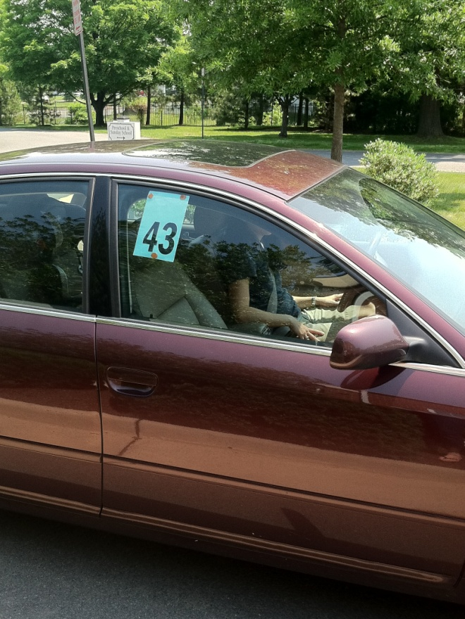

Page 8

Staff members will open and close the car door but will not lock the doors. Drivers should then proceed to the north parking area to buckle in their child. Do not park behind parked cars or along the yellow areas as they are fire lanes and need to be kept clear at all times. All pre-school traffic must exit onto Spring Street.

St. Timothy’s

Pre-School

Portico

Spring Street

Fire lane

Fire lane

North Parking Area

C:\Users\rena\AppData\Local\Microsoft\Windows\Temporary Internet Files\Content.IE5\2FCCJFEI\MC900384278[1].wmf

Please remember that Virginia law requires that all children under the age of eight (8 years old) must be in an appropriate car/booster seat whenever they are in any vehicle. Also, no child should ever be in the front passenger seat of a vehicle.

**LATE** **PICKUP**

Because it is very important to children and the staff, parents should be prompt at pick up time. A charge of $10.00 per day will be assessed for supervision of children not picked up by 12:05 P.M. If a child has not been picked up after normal closing time and the pre-school has not been contacted by the parent concerning the delay, the following procedure will be followed:

1. School will attempt to contact parents, if no response
2. School will contact Emergency Contact persons, if no response
3. School will contact Child Protective Services or Herndon Police Department

Page 9

**HOMEROOM**

Each homeroom class will have a volunteer Homeroom Parent who will act, at the teacher’s request, to coordinate donations for parties and other special events.

**SCHOOL PICTURES**

Professional school pictures will be taken in spring. Packages include class and individual pictures. The purchase of school pictures is optional. All parents will be asked to sign a waiver allowing teachers to take photos during class to be shared in class newsletters as well as the school website and Facebook page (No names are ever listed.)

**PARTIES**

Classroom parties are held to celebrate Valentine’s Day and St. Patrick’s Day. Other Special events, such as the Halloween Parade, Christmas, Donuts with Dad, Mother’s Day Tea and End of Year Picnics will be announced in newsletters.



Your child will receive a crown to wear in recognition of his or her birthday. Homeroom classes celebrate birthdays in different ways. Your child’s teacher will let you know how her class recognizes birthdays.

Invitations to “At home” parties cannot be distributed at school unless every child in the class is receiving an invitation.

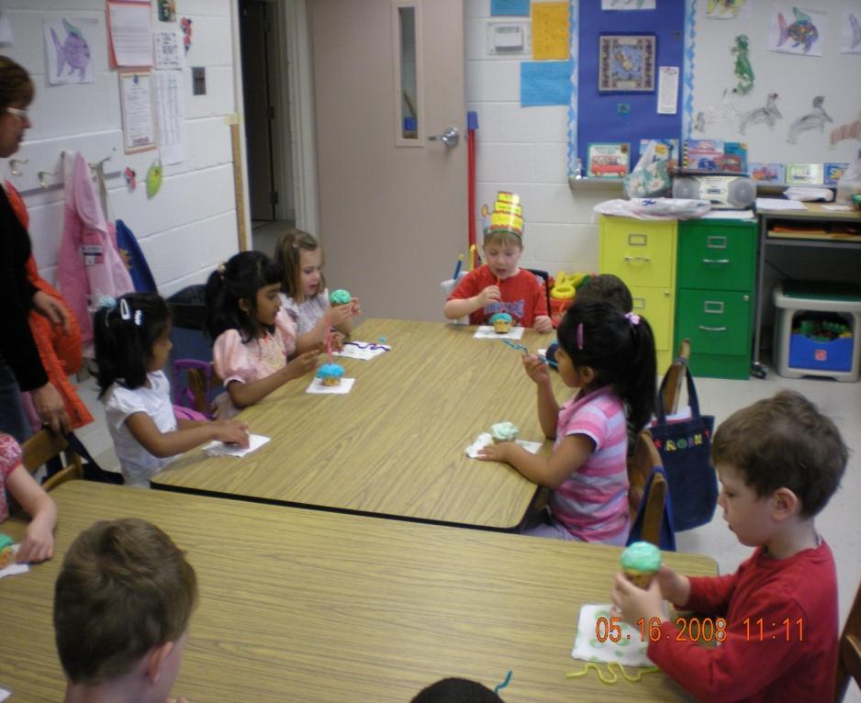

Page 10

**FIELD TRIPS**

Because of concern about traffic safety and security, the pre-school does a very limited number of activities away from the facility. Generally, outside resources will be brought into the classroom so that students may participate in a familiar setting. Each Homeroom head teacher will determine which field trips, if any, will be taken by her class.

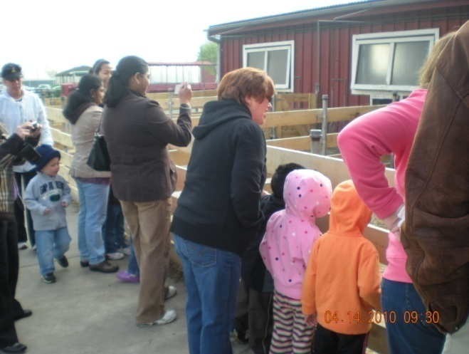

If a trip to another location is planned, parents will be notified in advance. Parents will be asked to volunteer by driving and helping to supervise children. Some field trips are not suitable for younger siblings. Parents will be told this in advance. State law requires that all children use the proper type of safety seat for their age and weight. Drivers must hold a valid driver’s license and vehicles must be insured and meet all Department of Motor Vehicle standards.

**SNACKS**

The pre-school provides a simple, nutritious snack each day.  The monthly menu appears on the back of the calendar.  The school's regular snack is provided to all of the children with the exception of children with medically confirmed food allergies.  Children with severe allergies will be asked to supply their own snacks.

Page 11

C:\Users\rena\AppData\Local\Microsoft\Windows\Temporary Internet Files\Content.IE5\4PLY0KLK\MC900412748[1].wmf

**SNOW DAYS AND LATE OPENINGS**

When Fairfax County Public Schools (FCPS) are closed for inclement weather, St. Timothy’s will be closed and those days will not be made up. Please watch for teacher emails and/or call the school office for updates.

The schedule for late openings is as follows:

|  |  |  |  |
| --- | --- | --- | --- |
| FCPS Openings | A.M. Session | Lunch Bunch | STEP |
| 1 hour late | 9:45 A.M.- 12:00 P.M. | 12:00-1:30 | 1:30-3:00 |
| 2 hours late | 10:45 A.M. – 12:45P.M. | 12:45-2:10 | 2:10-3:30 |

Clarification: When you hear a message about Fairfax County Pre-schools they are referring to the Special Ed pre-schools that the county operates.

Page 12

**SUPPLIES**

All supplies shall be provided by the pre-school. Donations are happily accepted. Children should have a large tote bag or backpack marked with their names to carry their belongings. Please check the tote bags every day; you will want to review the papers and projects brought home. Backpacks with wheels are not allowed.

**TUITION**

Tuition is based on the annual amount as noted on the Parent/School Contract. It is paid in nine equal payments. The first payment (#1) is due on June 1st or upon later enrollment. **Payment #1 is a non-refundable payment.**  Subsequent payments #2 - #9 are due on the 1st of each month beginning in September the last payment being in April.

Payment by check, cash or automatic bill pay is preferred. Credit card payments will also be accepted with a 2.5% processing fee. Payments may be sent by mail, in your child's bag or handed to staff in the carpool line. If a bank is sending your payments, the child's name should appear in the memo line. If the 1st falls on a non-school day such as a weekend or holiday or your child is not in school that day because of illness, the payment is due the next day the child attends. Checks received in advance of the 1st, but dated the 1st, shall be held for deposit until the 1st.

A late fee of $25.00 is to be automatically added to the tuition rate if the payment is received later than the 5th of the month.

A charge of $35.00 will be assessed for any declined payment.

Please contact the Director in case financial difficulties arise so that suitable arrangements can be made.

Page 13

APPENDIX I

# **LICENSING INFORMATION FOR PARENTS**

# **ABOUT CHILD DAY PROGRAMS**

The Commonwealth of Virginia helps assure parents that child day programs that assume responsibility for the supervision, protection, and well-being of a child for any part of a 24-hr day are safe. Title 63.1, Chapter 10 of the Code of Virginia gives the Department of Social Services authority to license these programs. While there are some exemptions to licensure, licensed programs include child day centers, family day homes child day center systems, and family day systems. The state may also voluntarily register family day homes not required to be licensed.

Standards for licensed child day centers address certain health precautions, adequate play space, and a ratio of children per staff member, equipment, program, and record keeping. Criminal records checks and specific qualifications for staff and most volunteers working directly with children are also required. Standards require the facility to meet applicable fire, health, and building codes.

Compliance with standards is determined by announced and unannounced visits to the program by licensing staff within the Department of Social Services. In addition, parents or other individuals may register a complaint about a program which will be investigated if it violates a standard. Operating without a license when required constitutes a misdemeanor which, upon conviction, can be punishable by a fine of up to $100 or imprisonment of up to 12 months or both for each day’s violation.

If you would like additional information about the licensing of child day programs or would like to register a complaint, please contact the Regional Office of Social Services, Fairfax Licensing Office, 3959 Pender Dr., Suite 320, Fairfax, VA (703) 934-1505.

**POLICY FOR REPORTING SUSPECTED CHILD ABUSE**

In accordance with S63.1-248.3 of the Code of Virginia, any suspected incidence of child abuse or neglect must be reported to the local Child Protective Service office. Concerns about an individual child will be brought to the Director who will contact the appropriate agency. These concerns will be documented in writing and maintained in a private file by the Director.

Page 14

APPENDIX II

## **GUIDELINES FOR DISCIPLINE**

Discipline shall be constructive in nature and include techniques such as:

1. Using limits that are fair, consistently applied, and appropriate and understandable for the child’s level;
2. Providing children with reasons for limits;
3. Giving positively worded directions;
4. Modeling and redirecting children to acceptable behavior;
5. Helping children to constructively express their feelings and frustrations to resolve conflict;
6. Arranging equipment, materials, activities, and schedules in a way that promotes desirable behavior.

There shall be no physical punishment.

If it is necessary to use separation from the group as a disciplinary technique, it shall be brief and appropriate to the child’s developmental level and the circumstances. The child will be directly supervised by a staff member.

## **TERMINATION OF ENROLLMENT**

If it becomes necessary for a parent to withdraw a child from the program, thirty days written notice or one month’s tuition is required.

The pre-school reserves the right to terminate enrollment of any child that the pre-school has determined presents a danger to himself or others. This would include, but not be limited to: children who cannot participate fully because the program is not appropriate for the child’s developmental level; children who exhibit inappropriate or aggressive behavior and are not responding to positive steps taken by the staff; and, children who present a health hazard to others.

Communication between staff and parents is critical. If problems arise, parents will be notified immediately. The staff will relate to the parent what steps are being taken to resolve any problems and will ask for the parents’ suggestions and cooperation. If the pre-school determines that a situation cannot be resolved satisfactorily, a two-week notice will be given to the parent stating that the child’s enrollment will be terminated and giving specific reasons for the termination.

Page 15

APPENDIX III

## **MEMORANDUM**

Date: January 3, 1994

To: Tenants, Building Occupants, Employees, and Staff

From: St Timothy’s Pre-School

432 Van Buren St.

Herndon, VA 20170

Re: Availability of Asbestos Management Plan

Location of Asbestos

In October of 1986, the U.S. Congress enacted the Asbestos Hazard Emergency

Response Act (AHERA). Under this law, comprehensive regulations were developed to address asbestos problems in public and private elementary and secondary schools. These regulations require most schools to inspect for friable and non-friable asbestos, develop asbestos management plans that address asbestos hazards in school buildings and implement response actions in a timely manner.

These regulations assign schools many new responsibilities. A building inspection for

The presence of asbestos has been made and an operations and maintenance plan has been placed into being. This plan contains information on our inspection, re-inspection response actions and post response action activities, including periodic surveillance activities that are planned or are in progress.

You can review this plan during normal business hours without cost or restriction.

### **Summary of Inspection**

Of all areas tested at the property listed above, only the floor tile and mastic were found to contain asbestos. No special precautions need be taken during any demolition and/or subsequent renovation to any area or material found within the building unless the floor tile is to be impacted or a substance not specifically addressed in this report is found.

Page 16

APPENDIX IV

General*

EMERGENCY PROCEDURES

# **Type I (ex: intruder, worsening weather, power failure, etc.)**

* For **INTRUDER**:
* Loud sustained whistle alerts everyone to emergency.
* Call 911 from any/all phones.
* All children and staff remain in place.
* Staff closes and locks doors, and turn off light, cover door window if possible.
* Staff and children stay in room until Director declares that the school is safe.
* Staff does not discuss emergency in front of children.
* For **WORSENING** **WEATHER or POWER FAILURE ETC.:**
* All children and staff return to Homeroom classroom and close door.
* Staff does not discuss emergency in front of children.
* Children will be prepared to leave.
* Parents will report to office and stay there until child is brought to them.

# **Type II (ex: biological attack, tornado, etc.)**

* A sharp intermittent whistle alerts everyone to emergency.
* Heat/AC turned off.
* All children and staff report rear hall.
* Bring **ALL** coats, school bags, purses, cell phones
* **BRING** copy of emergency roster w/parents phone #’s
* Office phone(s) will be brought to rear hall.
* Supplies in emergency cabinet:

water, food, tape

first aid kit

radio & extra batteries

flash light, emergency lights, blanket

art supplies, books

Depending on emergency, Director (or Asst.) will be either in office or in safe room area.

*The **COMPREHENSIVE** Emergency Preparedness plan is available for review in the pre-school office.

Page 17

APPENDIX V

CLASSROOM DAILY SCHEDULE

**Arrival begins 8:45 A.M.**

**Homeroom (Placement by Age) 8:45 – 10:00 A.M.**

**Arrival – books, toys, games, puzzles**

**Show and Tell – discuss items brought, share news**

**Calendar – weather, days of week, month and date**

**Activity – readiness activities**

**Open Time (Multi-age groups) 10:00 – 10:50 A.M.**

**Art Room – creative activities, varied art techniques and media, discovering well-known works of art**

**Butterfly Room (Science & Nature) – experimenting activities, nature studies, basic scientific concepts, sand table, water play**

**Ladybug Room (Math) – block play, number concepts, guided and free, exploration with manipulatives**

**Quiet Room – books, puzzles, quiet table play, small manipulatives**

**Play Room – free play activities, dress-up, kitchen area, dramatic play**

**Music Room – fundamentals of music through song and creative movement**

**Library -- listening center, flannel board stories, literature activities**

**Snack Room – simple, nutritious snack served**

Clean-Up Time & Story Time 10:50 – 11:00 A.M.

Homeroom 11:00 – 11:45 A.M.

Outdoor activities, playground, walks, organized games

Indoor activities, stories, songs, sharing

Preparation to leave

Page 18